Periodic Trends Exercises :D
a) Define electronegativity and explain its trend across a period and down a group.
________________________________________________________________________________________________________________________________________________________________________________________________________________________________________________________________________________________
b) Compare the atomic radius of lithium (Li) and fluorine (F) and explain the difference.
________________________________________________________________________________________________________________________________________________________________________________________________________________________________________________________________________________________
c) State the first ionization energy trend across a period and down a group.
________________________________________________________________________________________________________________________________________________________________________________________________________________________________________________________________________________________
d) Explain the relationship between electron shielding and ionization energy.
________________________________________________________________________________________________________________________________________________________________________________________________________________________________________________________________________________________
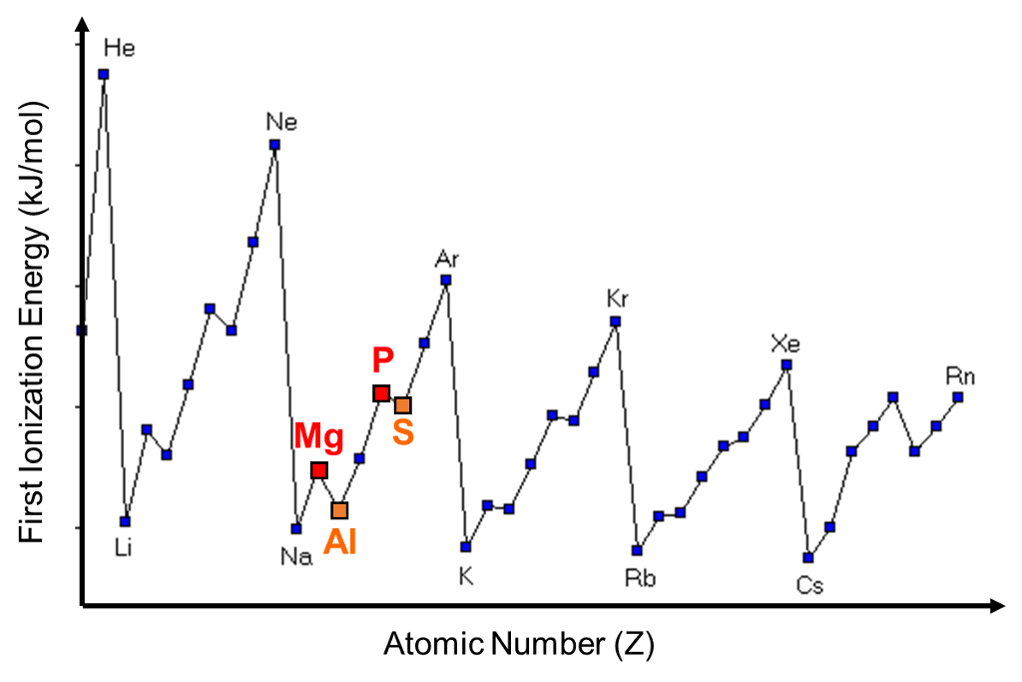
e) Justify why oxygen is more reactive than sulfur in terms of periodic trends.

____________________________________________________________________________________________________________________________________________
f) The image on the right shows interesting peaks for the ionization energy of different atoms. Explain the trend you see and highlight why there are certain peaks and valleys.
________________________________________________________________________________________________________________________________________________________________________________________________________________________________________________________________________________________
________________________________________________________________________________________________________________________________________________________________________________________________________________________________________________________________________________________

Electron Structure & Bonding Exercises :D
a) Define electron shielding and describe how it affects atomic size.
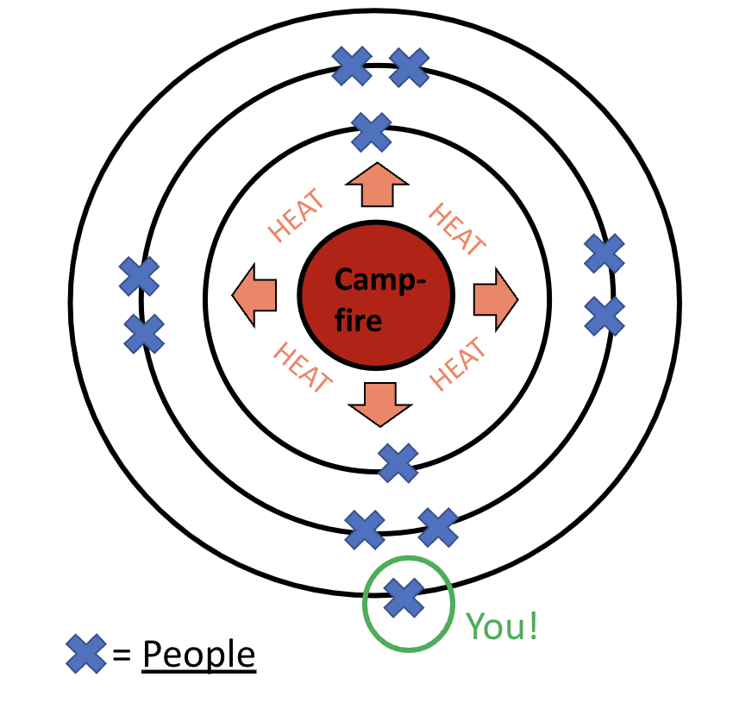
________________________________________
________________________________________
________________________________________
________________________________________
________________________________________
________________________________________
________________________________________

a2) The image on the right shows an analogy for electron shielding. Fill in the table below with the correct connection to the image.
Atomic part | Analogy in image
Nucleus
Electrons
Heat
Rings

Element | Electronegativity
Mg | 1.31
Cl | 3.16
O | 3.44
N | 3.04
b) Identify the type of bonding in the following compounds and justify your choice:
  - MgCl₂
  - N₂
  - Cu
____________________________________________________________________________________________________________________________________________

c) Determine if the bonds are ionic, polar covalent, or nonpolar covalent.
________________________________________________________________________________________________________________________________________________________________________________________________________________________________________________________________________________________________________________________________________________________________________________________________________________________________________________________________________________________________________________________________________________________________________________
d) Compare and explain the melting points and electrical conductivity of ionic, covalent, and metallic compounds.
________________________________________________________________________________________________________________________________________________________________________________________________________________________________________________________________________________________________________________________________________________________________________________________________________________________________________________________________________________________________________________________________________________________________________________
e) Explain why water is a polar molecule while methane is nonpolar.
________________________________________________________________________________________________________________________________________________________________________________________________________________________________________________________________________________________________________________________________________________________________________________________________________________________________________________________________________________________________________________________________________________________________________________Naming Ionic Compounds YAAAAAY
a) Name the following ionic compounds:
  - Na₂SO₄
  - FeCl₃
  - Cu₂O
  - (NH₄)₂CO₃
b) Write the chemical formulas for the following compounds:
  - Magnesium nitrate
  - Iron(II) sulfate
  - Copper(I) bromide
  - Ammonium phosphate
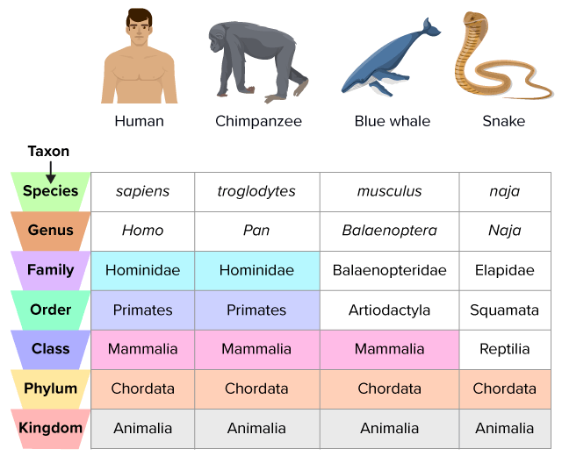
Taxonomy & Yassification (classification)
a) Arrange the following taxonomic ranks in order from most general to most specific: Order, Phylum, Genus, Class, Kingdom, Species, Family.
Figure 1

b) Explain why all humans are primates, but not all primates are humans.
_______________________________________________
_______________________________________________
__________________________________________________________________________________________________________________________________________________________________________________________________________________
b2) Using the figure 1, describe whether a snake is closer related to a blue whale or to a chimpanzee. ____________________________________________________________________________________________________________________________________________
c) Two organisms share the same order but different families. What does this tell you about their relationship?
________________________________________________________________________________________________________________________________________________________________________________________________________________________________________________________________________________________
d) Explain how DNA sequencing has improved the classification of organisms compared to physical characteristics.
________________________________________________________________________________________________________________________________________________________________________________________________________________________________________________________________________________________________________________________________________________________________________________________________________________________________________________________________________________________________________________________________________________________________________________
Bonding and Chemical Rawractions (reactions)
a) Draw the electron shell diagrams for magnesium and oxygen, and illustrate the transfer of electrons when they form an ionic bond.

b) Describe how metals conduct electricity.
________________________________________________________________________________________________________________________________________________________________________________________________________________________________________________________________________________________
c) What kind of metallic bond would adding copper to iron create.
________________________________________________________________________________________________________________________________________________________________________________________________________________________________________________________________________________________

d) Balance the following chemical reaction and identify the type of bonding in the product:
__ Al + __ O₂ → __ Al₂O₃

e) Compare the bonding in NH₃ vs. CO₂, including polarity and molecular shape.
________________________________________________________________________________________________________________________________________________________________________________________________________________________________________________________________________________________
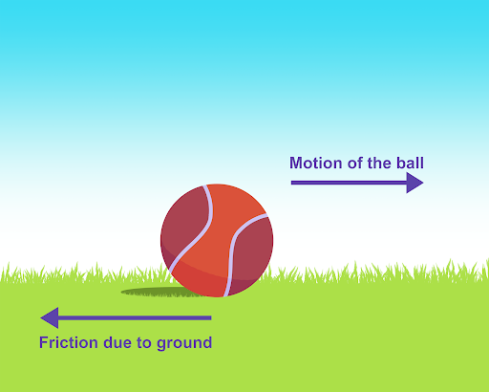
Forces & Motion
Draw the missing forces on the image to the right.

Describe the movement, or lack thereof, of the ball in the image.
____________________________________________________________________________________________________________________________________________
A cyclist is moving at a constant velocity. What is the net force acting on them? Explain.
________________________________________________________________________________________________________________________________________________________________________________________________________________________________________________________________________________________
A child pulls a wagon with a force of 60N to the right, while friction exerts a 25N force to the left. Calculate the net force and describe the wagon’s motion.

________________________________________________________________________________________________________________________________________________________________________________________________________________________________________________________________________________________
Draw a free-body diagram for a boat accelerating forward on water and explain the forces acting on it.

Bonding Properties Analysis
Given the table below, classify each substance as metallic, ionic, or covalent bonding and justify your reasoning.
Substance | Bond Type | Conducts Electricity? | Boiling Point (°C) | Malleable?
X | ? | Yes | 2500 | Yes
Y | ? | No | 120 | No
Z | ? | Yes (only when melted) | 1400 | No
Forces in Real Life
a) A rocket is launching upwards. Compare the thrust force and gravitational force at different moments of the launch.
________________________________________________________________________________________________________________________________________________________________________________________________________________________________________________________________________________________
b) An airplane is cruising at a steady speed. Compare the lift and weight forces acting on it.
________________________________________________________________________________________________________________________________________________________________________________________________________________________________________________________________________________________
c) A horse pulls a cart with a force of 100N forward, while friction exerts 40N backward. The normal force is 300N, and gravity is also 300N. Sketch this situation and calculate the net force and describe the cart’s motion.

d) A person pushes against a wall with 150N of force, but the wall does not move. What can you conclude about the forces acting on the person and the wall?

